Technical requirements for the reception of TV commercials
Effective as of 01.01.2025 – valid for file formats via FTP
The technical requirements for the reception of all TV commercials spot in high definition (HD) are specified as follows:
1) Supplied materials must be recorded in files formats XDCAM. Files must be supplied without any defectse. For access codes to FTP server contact us on Strakac.Oto@markiza.sk.
2) The HD video signal must be recorded in the 1080i25 format.
3) Audio signal of all delivered commercial spots have to be normalized according to the EBU R128. The alghorithm of the loudness measurement is defined in ITU-R BS.1770.3 and EBU Tech doc 3341. Target level for the commercial spot loudness has to be -23.0 LUFS. Maximum true peak level must not exceed a maximum of -1 dBTP (based on the digital full scale of 0 dBFS). Loudness range can not exceed 15 LU. For commercials spots shorter then 30 seconds Momentary Loudness must not exceed -15.0 LUFS and simultaneously Short Term Loudness -20.0 LUFS.
4) Programs consisting of both music and speech must respect the balanced physiological perception of sound, i.e. music and spoken word must be perceived at an equal volume level see EBU R128.
5) The offset (time shift) between the picture and sound must be subjectively imperceptible,
6) All files must be delivered in file format MXF op1a container. File based time code must always begin at 00:00:00:00. Only standard letters must be used for the name of the file. The name of the file must be the same with the name of the spot.
7) Sequence of audio tracks: 2 audio tracks: A1,A2 SK Stereo
8) Coding for HD:
Profile: XDCAM HD 422
Data flow: 50Mbps CBR
Aspect ratio: 16:9
Resolution: 1920x1080
Audio codec: PCM
Sampling rate: 48kHz
Bit depth: 24 bit
Subtitles and graphics must always be placed only in the active part of the picture signal. A safe range is specified in the EBU R95-2000 recommendation. For programs in 16:9, it is 5% under the upper or above the lower edge and 10% from the left or right edge.
Further to the point 6.1 of Article 6. of the Contract Conditions for the broadcasting of commercial media communication in the programme services of the respective calendar year published on obchod.markiza.sk ("Zmluvné podmienky"), the uniform text of the warning in the advertisements of pharmaceutical companies and in the advertisements of traditional herbal medicine companies must have the size of the capital letter "P" 1/33 of the height of the entire image (also behind crop).
Recommended fonts are Arial Regular (in AfterEffects size 37px for HD) Nimbus Sans D OT Regular (in AfterEffects size 37px - HD) Lucida Sans Regular (in AfterEffects size 37px - HD) Helvetica Bold (in AfterEffects size 36px - HD) Futura Medium (in AfterEffects size 37px - HD). Colour must be such that the difference between script and backgound after transfer to grayscale must be more than 50% of the whole scale.
Unified warning text for pharmaceuticals products is following:
„Pred užitím lieku si pozorne prečítajte poučenie o správnom používní lieku obsiahnutého v písomnej informácii pre používateľov liekov, ktorá je pribalená k lieku.“

Which means “ Before taking the medicine, read carefully the instructions on the correct use of the medicine contained in the written information for medicine users that comes with the medicine.”

Unified warning text for traditional herbal medicinal products is following:
"Tradičný rastlinný liek určený na indikácie overené výhradne dlhodobým používaním."
Which means “Traditional herbal medicinal product for indications verified exclusively by long-term use.”

All supplied HD masters must be 1080i25 (whether the original acquisition was 1080p25 or 1080i25). (Note: This format is sometimes wrong marked as 1080/50i – for example Avid Edits). Also all digital special effects, moving subtitles and graphics must be in 1080i25 format so that undesirable vibrations of the picture are prevented.
9.) Requirements for injection image: TGA/TIF sequence, 25fps, if 16x9 WideScreen PAL 720x576, or 1024x576, square pixel or if 4x3 then PAL 720x576 and logo in vector graphics and also in JPG picture.
10.) Customers take into consideration that station logo with countdown has dimension 266 x 110 px. Is placed in upper left corner 428 px from left side and 177 px from upper side.
See picture :
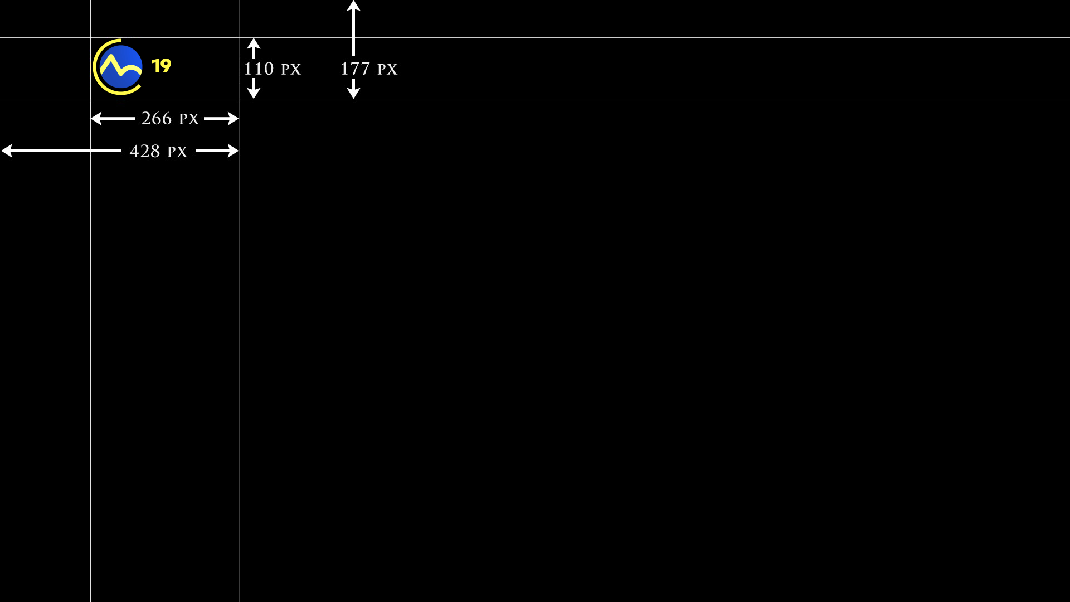
It is also necessary to provide accompanying documentation, which includes details of the music used in the score to the extent specified in the Terms and Conditions.

